DKX3Self*-*signed certificate configuration procedure

【DKX3】

1. Log in to DKX3 WebUI → “Security” →　Certificate. Fill out necessary information as below →　Click “Create”

<E.g>

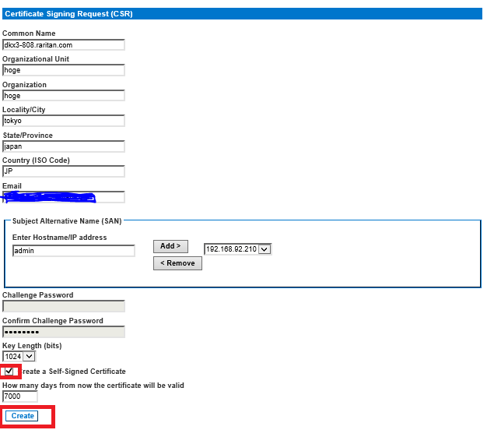

2. Once the below message pops up, click “**OK**”.

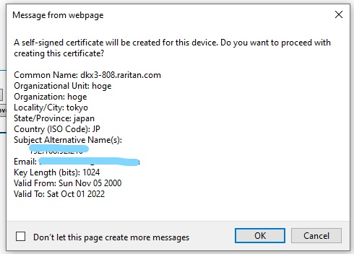

3. Installed successfully message as below pops up.

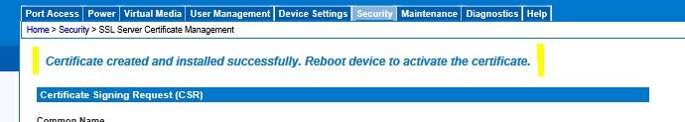

4. Maintenance → Reboot DKX3 via “Reboot”.

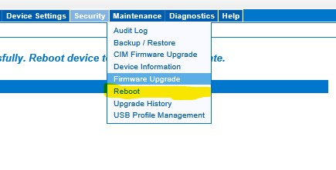

【Configure your self-signed certificate on IE】

1. Access to DKX3 on IE →　Go on to the website (not recommended)

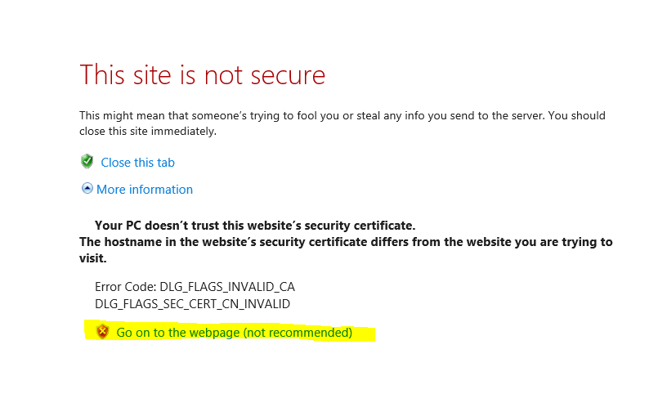

1. Click **View Certificate**

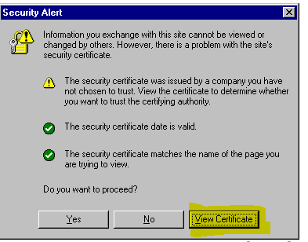

1. Click **Install Certificate**

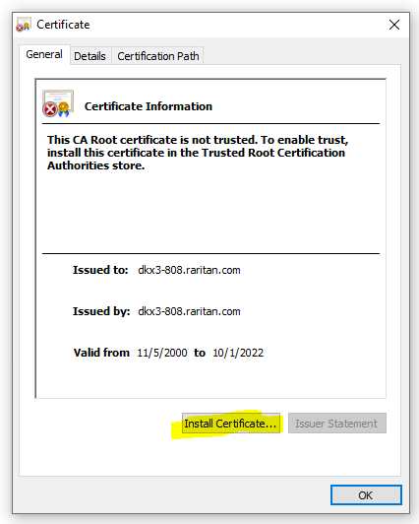

4. Click **Next** → Place all certificates in the following store → Browse →Trusted Root Certification Authorities →　OK

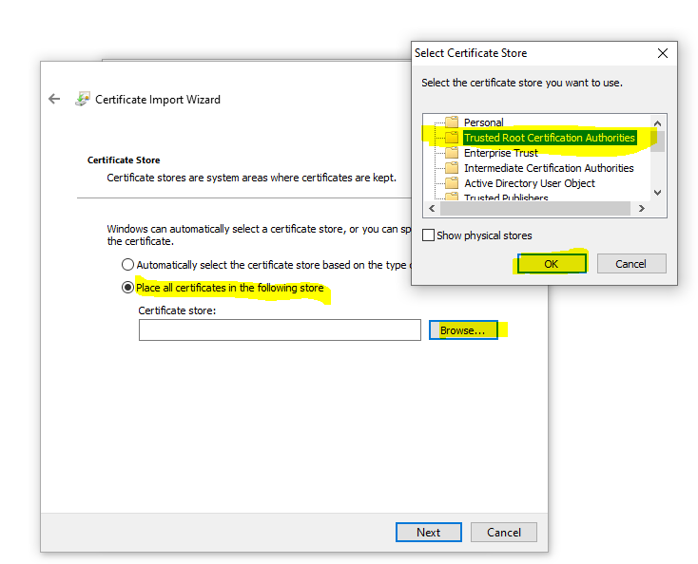

1. Click **Next →**Finish

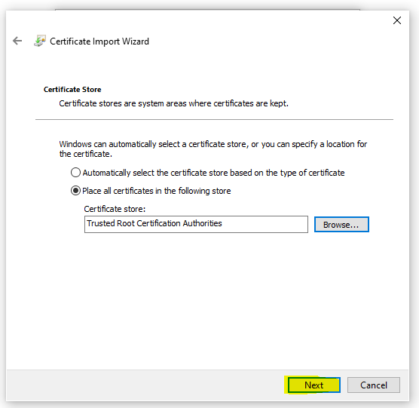

6. Chick **Yes** →　OK　(The import has been completed) →　OK

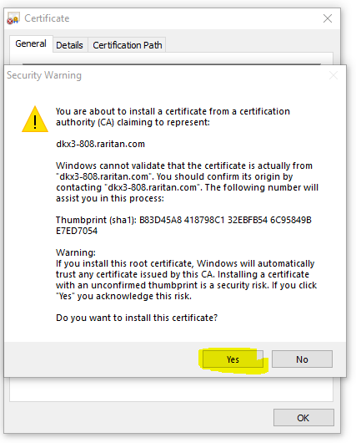

7. 　Open “Internet Option” on IE →　Advanced

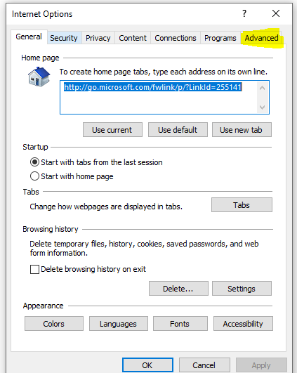

8. Uncheck “Check for server certification revocation” & “Warn about certification address mismatch.”　→　OK

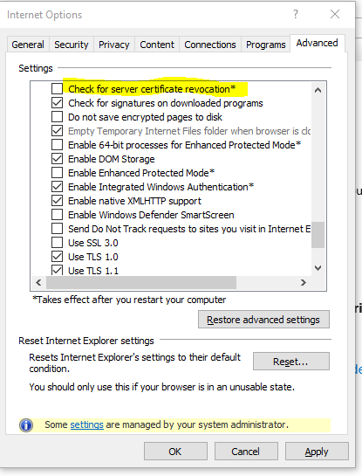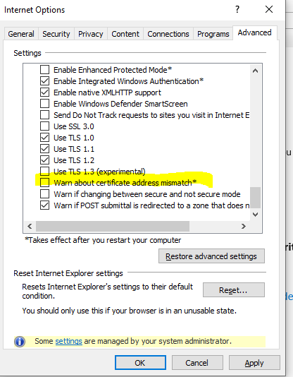

9. Reboot IE

10. Reconnect to DKX3 and make sure there is no Certificate Error.

